santas_united_tunnus_colourtext**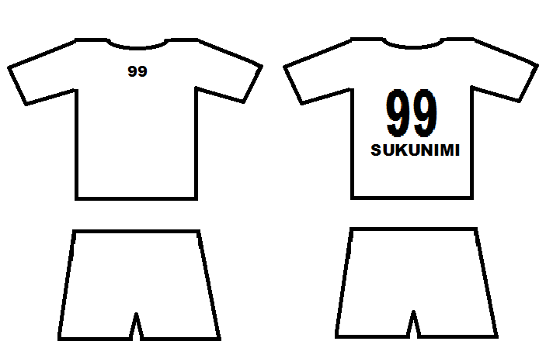**

OX

DOG

LOGO

Intersport

OXDOG



OXDOG

Eespert Oy

14

13

12

OXDOG

17

17

16

9

Minimani

**99**

11

15

2

1

4

3